Environment:
A Breeder ABGA Member :
We had a doe have triplets. This was her third time to kid. There had been no problems in any of the earlier birthing.
Symptoms:
At the time of birth, one of the kids had their back feet turned back. As he stood up for the first time, the hooves of the back feet were turned so that he was not walking on the hoof. He walked around and started nursing but the feet stayed in this same shape. The picture to the right was taken the next day after being born and the hooves are still turned backwards.
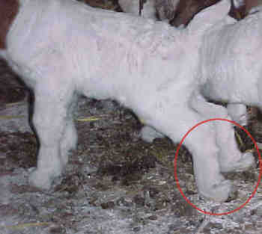
Action Taken:
- We decided to not do any taping or splints to help the foot straighten out to the natural form. We wanted it to correct on its own.
- The mother and kids were put in a small pen to allow the mother to stay close to her kids and make it easier for them to nurse.
- We watched him each day to make sure he was able to nurse and get to his mother.
- We decided if the feet did not start correcting on their own in three days, we would put a splint on the feet.
- The picture at the right was taken on the third day and one foot has corrected on its own.
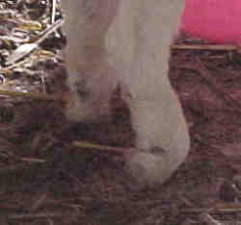
Results:
The feet corrected on their own in around five days. The picture to the right was taken on the fifth day and both back feet are now normal. This is not a real problem. It is basically from the hooves being turned backwards for an extended time prior to birth and natural movement of the feet after birth stretches out the tendons normally.
