Diarrhea is generally a symptom of a digestive system problem. There are numerous known infectious and parasitic causes of diarrhea as well as noninfectious causes. Noninfectious causes can include overfeeding, indigestion, lactic acidosis, copper deficiency and intoxications. The following describes some steps to take for identifying the source of the diarrhea. After identifying the proper symptoms check Diseases and Conditions here for possible treatments
- Review any changes to eating or feeding environment. Have you changed the type or amount of feed? Has the animal been grazing in a new or different pasture with different or more abundant food source? Getting off grain to just hay will help.
- Look at the age of animal. Is this a newborn or few weeks old animal? Diarrhea is a common problem during a kid's first few days of life. May be caused by chilling, erratic feeding, dirty bedding, dirty milk bottles and over eating. We use Spectam Scour-Halt (for pig scours) on our young kids with diarrhea and it really does a good job. Diarrhea in a 3-4 week-old kid is likely due to coccidiosis.
- Look at the color of diarrhea. Is is green or blackish? Green diarrhea can indicate an eating change.
- Check for internal parasites. Worms can cause diarrhea. The feces can be checked for parasite eggs present. This can be done by your veterinary or you can do it yourself. Also review site Veterinary Parasitology. Proper de-worming should take place if parasites are discovered.

Diarrhea  Article from Meat Goat Monthly News 5/2000 by Susan Gasparotto | Additional Material
Diarrhea should not be considered an illness in and of itself but rather a symptom of other more serious health problems in goats. Before treating a goat for diarrhea, it is essential to determine why the animal is scouring. Diarrhea-controlling medication can make the situation much worse. Slightly soft stool is sometimes the body's way of ridding itself of undesirable products through the purging effect of diarrhea. If the scouring is slightly soft stool, let it run its course. | 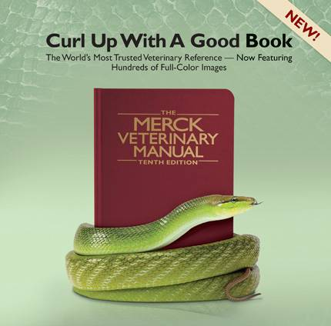
When body temperature is above the normal range of 101.5 to 103.5 F, use a fever medication and an antibiotic to control infection. Obviously, very watery diarrhea requires a different approach and much more intervention on the producer's part. For purposes of this article, my definition of "diarrhea" is anything other than perfectly formed goat pills.
There are four major causative agents of diarrhea in goats: bacteria, viruses, parasites, and management practices (i.e., overcrowding, poor sanitation, or nutritionally-induced problems such as overfeeding).
Diarrhea can be the symptom of many different illnesses, including bloat, ruminal acidosis, laminitis/founder, copper deficiency, aflatoxin poisoning, anaphylactic shock, plant toxicity/poisoning, renal failure, selenium toxicity, coccidiosis, enterotoxemia (clostridium perfringens type C&D), salmonellosis, E. Coli infection, caprine herpes virus, heavy parasite infestation, and goat polio. Always run a fecal examination on the goat's feces before attempting any treatment. See my website's article on how to do your own fecals (www.tennesseemeatgoats.com).
However, diarrhea is not always the result of an infectious disease. It can be nutritionally induced by overfeeding on milk or grain, by using poor-quality milk replacers, or by sudden changes in feeding schedules or in the type of feed being offered.
Neonatal Diarrhea Complex, which is the term used to describe diarrhea occurring in kids under one month of age, the cause of which may not ever be diagnosed, usually occurs during kidding season when extremes of weather take place excessive heat or cold or heavy rains. Kids less than one month of age do have not fully funetioning immune systems, so diarrhea can take a heavy toll. Dehydration, acidosis, electrolyte depletion,, and hypoglycemia (low blood sugar) can result. The kid becomes weak and can't stand, has a dry mouth and cold extremities, body temperature drops below normal, and the sucking response is often lost.
Sick kids should be isolated from the herd, placed in sanitary facilities, and fed in containers that are well above ground level to prevent further contamination. Administration of oral and subcutaneous electrolytes along with an ap'propriate broad-spectrum antibiotic is the recommended treatment. I prefer the oral electrolyte product ReSorb; sterile Lactated Ringers Solution (vet prescription) should be used for subcutaneous rehydratioin. In the case of Floppy Kidd Syndrome, one step in its proper treatment involves the use of a laxative (Milk of Magnesia) to induce mild diarrhea so that the kid's body is rid of the stagnant toxic milk that has overloaded its digestive system.
Coccidia and/or worms usually are the cause of diarrhea in kids over one month of age. Both of these conditions are transmitted by fecal-to-oral contact and occur most frequently in intensive management situations where pens and troughs are not kept clean and dry and where overcrowding exists. Accurate diagnosis of worm or coccidia oocyst infestation is possible only by doing a microscopic fecal count.
Adult-onset diarrhea is less common than in kids, but nevertheless is possible. Overfeeding on grain (such as shell or cracked corn) can cause severe ruminal acidosis... literally shutting down the goat's digestive system... and can result in death. Heavy parasite loads can cause diarrhea in adult goats. Almost anything which negatively affects the proper functioning of the goat's rumen may cause scouring.
When a producer sees diarrhea in one of his goats, do not run for a bottle of Pepto-Bismol, Kaeopectate, or Scour Halt. First figure out what is causing the scouring, then treat appropriately. Use a rectal thermometer to take the goat's body temperature. Do a microscopic examination of the feces. Check the goat for dehydration. Pinch the skin; if it snaps back into place, the goat is not seriously dehydrated. If the skin stays 'tented' like beaten egg whites, the goat is seriously dehydrated. Mix electrolytes ReSorb or equivalent) and orally drench the animal to prevent dehydration.
Never use Immodium AD' to control diarrhea in a goat. This product can stop the peristaltic action of the gut, bringing the digestive process to a halt, and death is not uncommon under such circumstances.
Producers should recognize diarrhea as a symptom of a more serious health problem and investigate further to find the cause before running for the medicine bottle. Sometimes, but certainly not always, the diarrhea is helpful in clearing up what is wrong with the goat.

