A Noodleville "How To": Copper Bolusing
I read many great blogs. I sit and read blogs more often than I post on my own…
Why?
Well, because most of them provide really useful info in an entertaining format… Throw in a healthy dose of life experiences/stories and I’m a happy reader.
My blog is mostly a place where I jot down various happenings in my life, but rarely do I post actual useable info.
Not sure how this is going to go, but I’m going to attempt to sporadically post useful “How To’s” in the future. Do note that I said sporadically…this gets me & my sporadic, hectic, unscheduled self off the hook for posting specifics at particular times.
So… Today’s “How To” is going to be about copper bolusing goats. In advance, I’ll forewarn y’all that this isn’t necessarily the gospel, it’s not the ONLY way to do things and I won’t be getting overly scientific on y’all.
Copper has been linked to fertility, parasite resistance, growth, resistance to disease, & general over all health. Most minerals do not provide adequate levels of copper to meet the needs of goats. Copper bolusing is a fantastic way to give a slow release copper supplement.
Copper deficiency can show itself in numerous ways. Also, blood samples are not a reliable way to check for copper levels in goats, the best way to check copper levels is by liver biopsy…Which can be performed during a necropsy (I personally don‘t know any vets willing to do it on a live goat, but it can be done). Handy for the goat owner to get a view on how things are going with their management… Not so handy for the goat having the necropsy.
So, here are a few outward signs of copper deficiency I can show you from my own goats (do keep in mind, these are not the only signs, just sharing a few from my herd).
Sabrina came to me looking a bit rough. Her diet had been a mineral block, heavy sweet feeds (covered in molasses, which is high in iron and high iron levels inhibit copper absorption), rationed alfalfa hay, unlimited grass hay and grazing/browse. If you look at her tail tip in this picture shortly after we brought her home you can see she has a “fish tail” with a bald tail tip and the remaining tail hair resembles a fish tail. Many goats will grow this hair back after proper mineral needs are met and maintained, some won’t. Sabrina’s has filled in some, though not fully so I’m still waiting to see if hers will fill in.
﻿
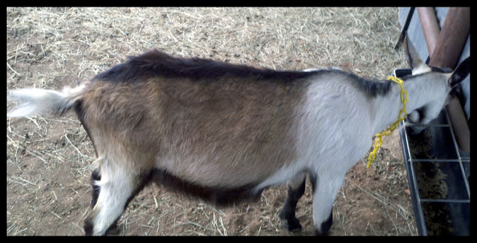
Sabrina 2011. Note the coarse coat & "fish tail"
﻿Next up is this burnt, coppery colored hair tips. No, this is NOT sun bleaching and it was also present on the dark hairs of her legs. Her previous home had loads of trees and shade was plentiful, where as here in the desolate, dry land of Noodle, trees and natural shade are sparse. For a fair comparison, I snapped pictures of her hair almost exactly one year apart so you can look at the difference and can compare winter hair to winter hair (In her before pics which were taken January 2011, she was pregnant & due in 2 months, in her after pics, taken January 2012, she only has 21 days left before her due date). Here we have minimal shade and if anything she spent MORE time in the sun than at her previous home, yet there are no burnt colored hair tips now. Her bald tail tip has filled in some as well, though not fully. The texture of the hair is also greatly improved. A year ago it was course and brittle, now it’s soft and has a healthy shine to it.
﻿
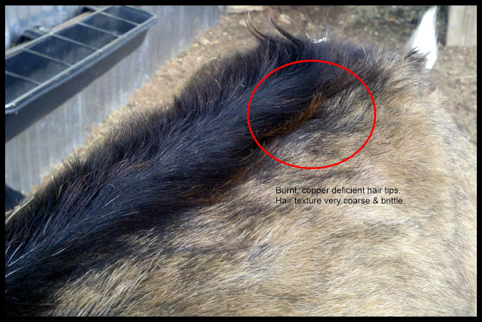
Before Copper. January 2011 Brittle, coarse hair. Discoloration affected all dark hairs
﻿
﻿
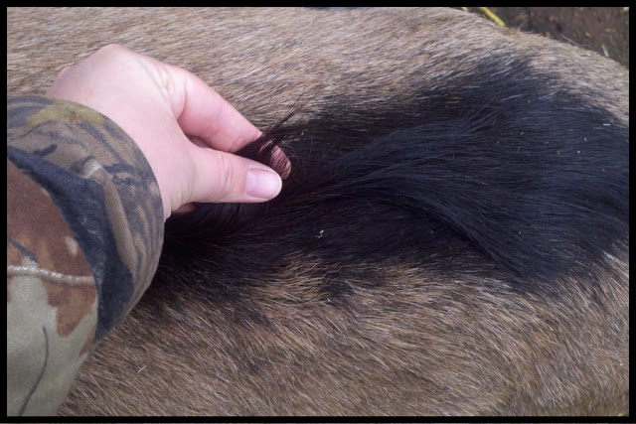
After Copper. January 2012. Hair has no discoloration, it's sleek, smooth (and covered in hay bits)
﻿ I didn’t think about it at the time, but I should have taken pictures of her feet. Good grief they were awful!! Her previous home kept her feet trimmed every 2 months, but the overall condition of the hoof material was very poor..... Now her feet are pretty normal and don't require as much effort to trim properly, nor do they have the tendency to grow misshapen as they did when she first arrived..
Another sign of copper deficiency is a fading out of the coat, or what some folks call "ghosting". Bleuberry shows deficiency this way. She has no noticeable "fish tail" or burnt hair tips. I can't give you pictures of her as I shaved her down and don't have the "before" pics to share.... Just keep in mind, that even within one herd, animals can display deficiencies differently.
To make a copper bolus I rely on the info provided by Joyce Lazzaro at Saanendoah. Her site will give you all the scientific, technical info on her copper studies (plus show you the other signs of copper deficiency not shown here). Fantastic read, great pictures and any goat owner really should take the time to read her information.
First you’ll need to buy a bottle of Copasure. I buy mine from Jeffer’s Livestock. These are copper boluses made up for cattle so you’ll need to break them down into smaller doses for goats. The $40+ may seem steep, but a little goes a long way so this should last you quite a while. I'll have to double check, but we bolused my mom's 3 miniature does, my 2 Lamanchas, and the 2 Alpine does & I think we used 3-4 of the boluses total and we typically bolus every 4 months.
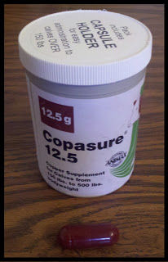
Copasure & a calf sized bolus
Using a postal scale, you weigh out the appropriate dose of copper needed for your goat. Repackage the rods into smaller gel capsules. I place the lil' foam pad from the Copasure container on my scale, zero it out, then pour on the copper rods.
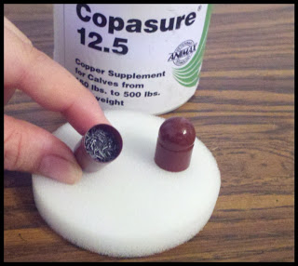
Copper Oxide rods inide a bolus

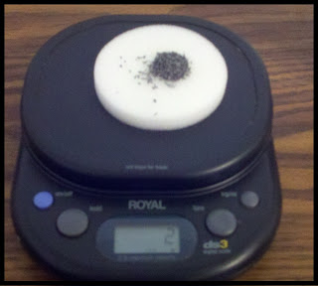
I buy the smaller gel capsules at the health food store, but recently noticed Jeffer's is now carrying them, as are several other online vendors. You can buy a variety of sizes but I personally prefer to package all my boluses in one size gel capsule & fill accordingly. I dose according to the data collected by Joyce Lazzaro which is 1 gram per 22lbs.
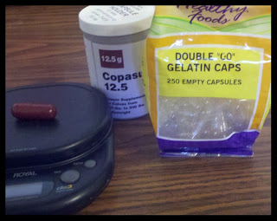

Next is the tricky part.
Ok, ok, I confess… I seem to be the only bolusing challenged person in the whole world!!!!!!!
I was instructed to use the smallest baling gun. I tried that. I got chomped up, spit out boluses. I found it too long, bulky, and thought it did a very poor job of holding the smaller bolus (even with peanut butter!). The goal here is to get the entire bolus swallowed WHOLE. Which means, using the baling gun, you hold open the mouth, put the baling gun as far back as possible…. I’m not talking just in the mouth. I mean over the back of the tongue and into the throat. Once in position you push the plunger and shoot the bolus, whole, down their throat.
I saw videos. I had helpful folks walk me through the process and give me 10,000 pointers. Yet, while all my goaty friends were swiftly, happily bolusing their goats, I was not. I tried empty horse dewormer tubes… Still a no go. I gave up, and went for an alternative method. Hiding the rods in treats. Sabrina would swallow an orange slice with a bolus in it with no problem. My miniature doe liked marshmallows. The rest? Not so much…they spit, chomped and basically did whatever possible to thwart me with every treat imaginable.
Sadistic lil critters!
Then I found my life saver in the form of a $2 piece of plastic.
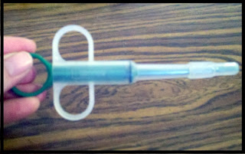
A bolusing challenged gals best friend!
This Pill Gun (known as the "Buster Pet Piller" from Jeffers) freaking rocks!!!!!
Granted, it’s not as long as a baling gun, so I have to hold their mouth open wide and get it back there but that’s no biggey. This lil pill gun firmly holds the bolus with a rubbery grip end, plus it also holds about 2-3ccs of fluid so when you push the plunger, fluid also comes out to help push that sucker right on down their throat.
Follow up with a treat while saying “Nummy, Nummy” and you’re all done! If you decide to use fluid in the pill gun (I do), make sure you dry the rubber gripper tip before putting the bolus in so it doesn't slip and to prevent the moisture from breaking down the gel cap prematurely.
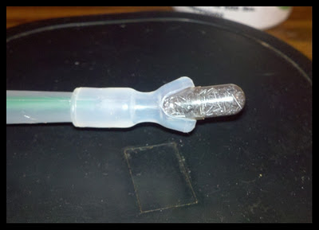
Just look at that nifty lil booger hugging my bolus!! Note- I wouldn't use a capsule bigger than 00 with this gun.
I say “Nummy, Nummy” in a "sing-song" voice while giving all oral meds to goats & children. I think it helps the process, my kids contradict me.
Now, a few things to keep in mind. In the front, goats only have bottom teeth, no top teeth, instead on top they have a hard “dental pad“. However, in the back they have both top and bottom teeth that are SHARP! Your dog’s molars have nothing on the molars of a goat and I promise you, you do not want to get your fingers caught!
Here is a handy picture showing you the anatomy of a goat’s mouth. You can see the lower incisors in the front, the gap, then the razor sharp molars in the back.
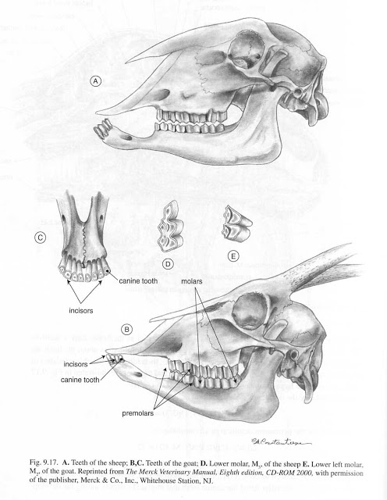
When bolusing, I straddle the goat, grab from the top and hold firmly in that toothless gap, careful to keep my fingers away from the chomping molars. Tilt the head back, push pill gun up over the tongue and as far back as I can get it, then push the plunger, close their mouth and shove a treat in!! With Bleuberry, I'm not tall enough to straddle her, so I lock her in the milkstand to bolus her. Easy Peasy! So easy in fact, that Clayton, my 8 year old, bolused Casper without a single problem….No spit out boluses, no chomped boluses, and no missing fingers.
Now, there is some debate on whether or not bolusing via treats is as reliable as the traditional baling gun (or pet pill gun) method, I‘m not getting into all that here. I did the treat method out of desperation, but in all honesty, I prefer the pill gun and giving full, un-chewed boluses. That way I KNOW without a doubt that they received their full dose.
Here is a nifty lil diagram illustrating how the bolus actually works:
﻿
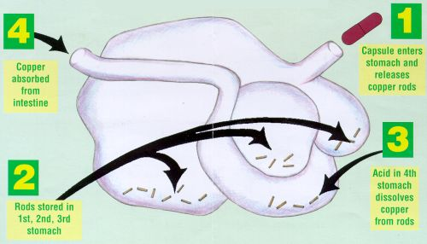
How the bolus works. Photo courtesy of Joyce Lazzaro by way of Animax Vet
﻿ Now, do keep in mind that copper is just one part in the mineral equation. Depending on your area you may have other deficiencies to worry about. For my area, and my herd, I have best results copper bolusing every 3-4 months, and I also give Bo-Se which is an injectable Vitamin E/Selenium that you can obtain with a vet RX. In addition to this I feed a high quality LOOSE mineral.
Emphasis on LOOSE mineral, as in bagged and similar to coarse sand in texture. Yes, there are mineral blocks available, but have you ever been licked by a goat? If not, come over and I’ll set Sabrina on ya.
Goats have very smooth tongues like a dog does which make it a bit more difficult to get all they need simply by licking at the block. Mineral blocks are typically full of cheap salts, so the goat needs to consume more of the block in order to meet it’s mineral needs. Problem is, the goat is attracted to the mineral block because of the salt and they typically get their fill of salt before they’ve come close to consuming the necessary amount of minerals. So all in all, while it’s a convenient concept, to me, a mineral block is worthless.
There are a variety of loose minerals on the market. Steer clear of “Sheep & Goat” minerals. Copper is toxic to sheep, while studies have shown that goats need a good bit of it, so a mineral safe for sheep just isn’t going to come close to meeting a goat’s copper needs. I prefer to buy dark, loose minerals…grey, brownish ones. The red ones usually contain higher levels of iron and iron inhibits copper absorption. Add in that many of the red minerals have iffy amounts and sources of copper to begin with and it’s just not worth the money. The best I could find, in my area is Cargill Right Now Onyx, a cattle mineral and the goats seem to do great on it and readily consume it, so I’m happy.
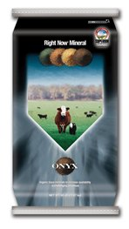
My loose mineral of choice. A 50lb bag last FOREVER.
To be truly scientific I even tried a few for comparison.... And yes, by "tried", I mean I went on a taste testing spree.
I licked a mineral block, a salt block and tried a pinch of the Cargill Right Now Onyx loose mineral. Salt block obviously was the saltiest. That mineral block was almost as salty as the pure salt block, with a hint of earthy undertones and the Right Now Onyx was just gross (or should I say "very earthly"?)… I could taste a SLIGHT saltiness, but it was barely there… So given that controlled, uber scientific experiment, I have proven that my loose mineral of choice isn’t chock full of cheap, filler salts.
True, I also read the labels as well, but the taste testing, IMO, made the whole thing more legit.
Also, a side note… Copper boluses are made of copper OXIDE. I see some folks grabbing bottles of copper SULFATE and just pouring who knows how much into their water troughs, and some who even have fed it via syringe. Do keep in mind that there is such a thing as “Too much of a good thing”. The copper OXIDE rods in the bolus dissolve slowly over a period of MONTHS in the digestive tract of the goat and when used properly, pose no risk of copper toxicity. The copper sulfate CAN be toxic and it is not a gradual release form of copper supplementation....
Anywho, just look how pretty Sabrina is now!
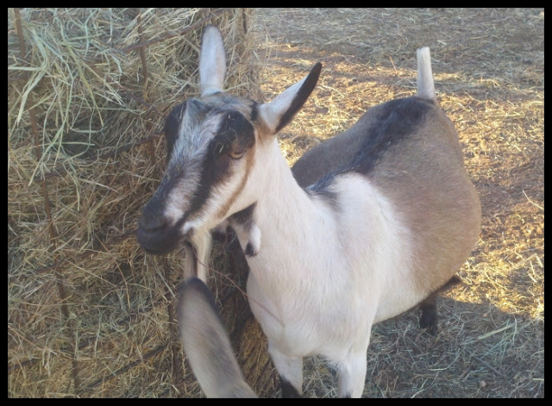
No coarse hair, no coat discoloration, no more hoof issues
.
Before her diet was heavily processed sweet feed in huge amounts (4 1/2+lbs of 16% sticky sweet feed per day), browse, a flake of alfalfa hay, mineral block and grass hay free choice. Here we switched it up a bit.
She now gets 17% protein, Standlee alfalfa pellets, good quality coastal & sudan hay, LOOSE minerals and her grain ration is a 12% protein mix of 2 parts whole oats, 1 part Purina Strategy Healthy Edge horse feed (lower protein, high forage content high fat/calcium feed) top dressed with black oil sunflower seeds or rice bran pellets…..When milking she consumes no more than 3lbs of grain per day (usually 1lb each milking) and last lactation she milked 14lbs at 2 weeks fresh. Plus she maintains great condition. So, in summary, she actually looks better on LESS feed.
The diet is made up of quality forage (alfalfa & hay), proper minerals and minimal grains. I find many folks will buy the poorest quality hay for goats, when in fact, I find my money better spent when I choose the best quality I can afford. Making the bulk of my herd’s diet alfalfa and quality hay enables me to have better production, better condition on a lot less of the concentrates (grain/pelleted rations) Not to mention the overall health of the herd is much, much better. Good forages make for a happy, healthy rumen. Proper minerals improve the overall health.
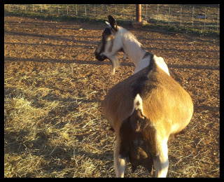
Sabrina's pregnant belly January 2012. Such a huge difference in overall condition when compared to last year. Kids due January 26th.
Many people think I’m nuts…after all they are “Just goats, they can eat anything” but the proof is in the pudding my friends! Which, BTW, not a clue how this got started, but goats do NOT eat anything, nor should it be considered ok to feed them food stuffs unsuitable for other livestock. They are actually picky eaters, preferring browse to grazing and if you watch them at the hay feeder they are constantly picking through it to find the best bite (which is why I feed alfalfa pellets.. They pick through the alfalfa hay, eat the leaves and waste a ton of stems..No waste with my alfalfa pellets). A horse will consume hay spilled on the ground and walked on, a goat won't unless that's the only thing available....
Anywho....usually the folks who think I'm nuts and advise me to use outdated methods of poor grass hay, lots of heavy sweet feeds and inadequate minerals are those with scraggly looking goats and they are the ones losing does to hypocalcaemia every kidding season.
No scraggly looking goats here, and my does receive enough calcium from their alfalfa that I’ve had no losses & no hypocalcaemia. Providing proper minerals i.e- copper, has also allowed me to deworm less frequently as well.....
Of course, each person has their own methods. I didn’t invent this stuff folks. I’m blessed to be advised by those who have decades of first hand experience and have been willing to help me out. In turn, I’ve tweaked things to suit my herd’s needs and my budget and all in all, I’m a happy goat owner with healthy goats.
I’ve said it once, I’ll say it again. If you have goats, I strongly urge you to read Joyce Lazzaro's Copper Studies (think I've linked to it enough in this post? lol)..
.
There are some interesting pictures of animals suffering from extreme copper deficiency as well as more in depth info than the brief review I provided.
Good stuff! by Crystal White (GOC)

