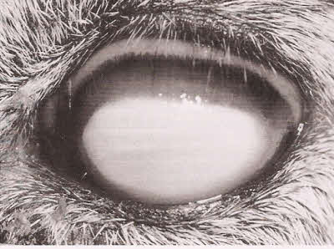 | 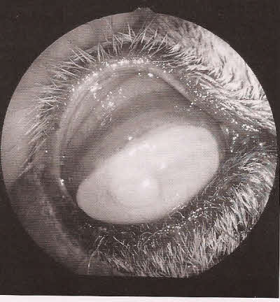
Mycoplasma Conjunctivitis | Chlamydia Conjunctivitis

Conjunctivitis is the swelling (inflammation) or infection of the membrane lining the eyelids. Pink eye is a common term used to describe many different diseases affecting the eyes of animals. It is an infectious and contagious bacterial disease of many animals including goats. It can be caused by several different microorganisms. Two of those microorganisms are Chlamydia psittaci ovis and Mycoplasma conjunctivae. The Chlamydia organism is the same organism that can cause abortions in does. The pink eye infection can be contagious to people so be careful when handling animals with this disease.
Pink eye generally will spread from a single animals to many others in your herd Spreading occurs from direct contact between each other or through flies or dust that can carry the bacteria to the eye. The condition is painful and may affect just one eye or both. Whatever causes the problem, the symptoms are similar. Those symptoms may include:
- blinking repeatedly
- an aversion to bright sunlight
- the side of the face below the eye may be wet from tearing
- the membranes of the eye appear red and inflamed
- the eyes become cloudy or opaque
- an ulcer may develop.
- can cause temporary blindness or permanent blindness in severe cases.

Treatment
Affected animals should be isolated from the rest of the herd to prevent the spread of the disease to other animals. Consider isolating them in a clean, dry, shady place.
Pink eye is usually treated with any number of antibiotics that are injected into the body or placed directly in the eye. The most common treatment is to apply terramycin ointment to the affected eye(s) two to four times per day. Some veterinarians recommend the use of intramammary mastitis tubes suchas as "Today" for the treatment of pink eye. As with the terramycin ointment, the antibiotic is applied directly to the eye. Here is an ointment we have used successfully. Triple Antibiotic Ophthalmic Ointment -Triple Antibiotic Ophthalmic Ointment is a combination of three antibiotics: Neomycin, Polymyxin B, and Bacitracin. It is used to treat bacterial infections of the eyes and eyelids. We do not use eye medication that is a spray or powder. They are more irritating to the already inflamed eye. The animal's face should be cleaned and the debris around the eye should be removed before applying the medicine. If the eye looks swollen, that can be related to inflammation and we will give Banamine injections in addition to the other treatments.
When we have an animal that is having cloudy eyes, we first treat with the ointment after putting drops of penicillin or Biomycin in the eye. If the clouding of the eye does not start clearing up in a day or two, we also start giving injections of the Biomycin under the skin once a day. If that does not seem to be helping, we move to a stronger antibiotic like Nuflor.
Despite intensive efforts, treatment may have little effect on the course or severity of the disease. Pink eye is similar to Sore Mouth) in that the disease is usually self-limiting and the majority of affected animals will clear up without treatment, usually in a week to 10 days. Severely affected animals may take longer to recover. Recovered animals have resistance for varying lengths of time. It is possible for them to become reinfected, as acquired immunity is not strong or long-lasting.

